Pyro 7 Ultra FAQ

1. How many receivers can a single Pyro 7 Ultra in transmitter mode connect to simultaneously?
In Non-Broadcast mode, a single Pyro 7 Ultra in transmitter mode can connect to a maximum of 4 receivers + 2 APPs (i.e., one-to-four reception + APP×2); in broadcast mode, a single Pyro 7 Ultra in transmitter mode can connect to 20 receivers (one-to-twenty), but broadcast mode does not support APP monitoring.

2. What power supply methods does the Pyro 7 Ultra support? How is battery life calculated?
The Pyro 7 Ultra supports two power supply methods:
- Integrated V-mount plate: Compatible with V-mount batteries (voltage range 12.8V~16.8V)
- DC power input: Supports 10~28V DC input
Battery life can be estimated by dividing battery capacity (Wh) by device power consumption:
- transmitter mode power consumption ≤25W
- receiver mode power consumption ≤20W
For example: Using a V-mount battery (14.8V/100Wh), transmitter mode battery life is approximately 100Wh ÷ 25W = 4 hours; receiver mode approximately 5 hours.

3. How to connect and operate the camera control function?
Taking Sony FX3 as an example:
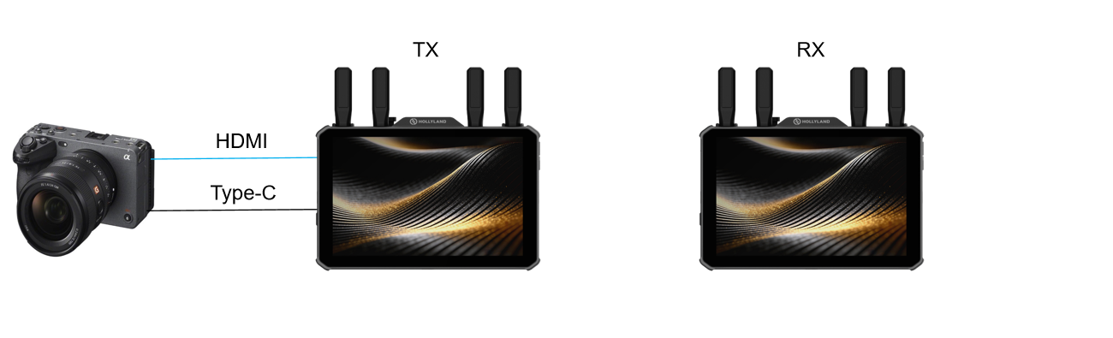
Connection Method 1 (Connect first, then configure):
- Use USB data cable to connect the camera USB port to the Pyro 7 Ultra Type-C port
- Camera pop-up window selects "USB connection mode" → "Remote shooting (computer remote control)"
Connection Method 2 (Configure first, then connect):
- Camera menu → "Network" → "Computer remote control" → Enable
- Connect USB cable
Topology: The camera connects to the Pyro 7 Ultra via HDMI cable (for video transmission) and via USB cable (for control signals) simultaneously.
Operation:
- Swipe left on the Pyro 7 Ultra home screen to enter the [Camera Control] template
- Adjustable parameters include: focus mode, resolution, frame rate, touch focus, playback, REC, ISO, aperture, shutter, WB, etc.
Note: Both transmitter and receiver can enter camera control mode, but only one monitor can perform control at a time.

4. How is the "one-to-twenty multi-person monitoring" function of Pyro 7 Ultra implemented? What is the maximum number of receivers it can support?
In Broadcast mode, the Pyro 7 Ultra transmitter can simultaneously transmit images to 20 receivers, making it ideal for directors, directors of photography, lighting crews, artist teams, and others to monitor simultaneously. Simply set all receivers to the same group as the transmitter (e.g., Group A) for automatic connection. In actual use, the number of receivers is only limited by the on-site wireless environment, with theoretically no upper limit.
Note: Broadcast mode does not support APP monitoring.

5. How does Pyro 7 Ultra achieve 20ms-level low-latency focus pulling guarantee? How to use focus pulling mode?
In smooth mode (with 1080p30 input), the Pyro 7 Ultra achieves wireless transmission latency as low as 20ms (professionally verified through 9851), precisely matching the stringent real-time requirements of focus pullers. Focus mode: Only in receiver mode, the focus mode icon will be displayed in the screen status bar (needs to be enabled in settings). Enabling this mode reduces latency.

6. What are the advantages of the 1500nits high-brightness screen and quantum dot wide color gamut of Pyro 7 Ultra? How to perform professional calibration?
1500nits high brightness: Combined with the optional detachable integrated sunshade, it enables clear monitoring under strong outdoor light without requiring an additional matte box.
Quantum dot wide color gamut: Combined with quantum dot film, it achieves ≥99% REC.709 color gamut with more delicate colors.
Professional calibration: Each unit undergoes Calman single-unit calibration (Rec.709, gamma2.4, D70) at the factory, with △E < 1.5. Users can also use the HL Monitor Calibrator for convenient on-site calibration, or import custom calibration files generated by third-party calibration devices in [Display Settings] (enabling calibration LUT will replace the factory calibration).
PS: △E = Color difference value, used to measure the gap between the screen display color and the standard reference color, unitless, the smaller the value, the more accurate.
- △E < 1.5: Professional film & TV grade color accuracy, human eyes can hardly perceive color difference, DaVinci / film monitoring standard
- △E < 2: Suitable for professional retouching and color grading
- △E < 3: Ordinary monitors
- △E > 5: Obvious color cast visible to naked eye

7. Which device ecosystems is Pyro 7 Ultra compatible with?
- Sony Venice series (under development and testing).
- Tilta follow-focus ecosystem: Connect to Tilta follow-focus system via Type-C, allowing direct control of follow-focus parameters on the monitor screen.
- Pyro ecosystem compatibility: Pyro 7 Ultra can seamlessly interconnect and combine freely with other devices in the same series (such as Pyro 7, Pyro 5 Pro, Pyro 5, Pyro Ultra, Pyro S, etc.), reducing multi-device replacement costs.

8. What convenient operations does the "new UI interaction system" of Pyro 7 Ultra offer? (Template management, left-right swipe switching)
Key highlights of the new UI:
- Swipe up from bottom: Summon the template management page, which provides four default templates: "Custom, Exposure, Focus, Composition", with a maximum of 7 templates that can be created, supporting template renaming. Each template allows free addition/removal of image analysis tools (such as waveform, zebra, focus assist, etc.).
- Swipe left/right on screen: Quickly switch between different function templates without navigating through layered menus.
- Swipe down from top: Enter display settings/function settings/system settings with clear logic.

9. How to use the two-finger touch zoom (infinite zoom) function of Pyro 7 Ultra? What is the maximum zoom ratio?
During real-time monitoring or video playback, use two fingers to touch the screen and spread outward to achieve 1~4x infinite zoom (continuous zoom). This function can be used to check focus details or composition edges, with image quality remaining clear during zooming.

10. Can the HDMI and SDI interfaces of Pyro 7 Ultra cross-output? In what scenarios is this useful?
Cross-output is supported. For example:
- If the transmitter inputs SDI signal (1080P60), then HDMI OUT loop-out can output that 1080P60 signal;
- If the transmitter inputs HDMI 4K60 signal, then SDI OUT loop-out can output the downgraded 1080P60 signal (SDI interface supports up to 1080P60).
Practical scenario: When both SDI monitors and HDMI monitors exist on-site, a single Pyro 7 Ultra can meet the monitoring needs of both interface types without requiring additional converters.

11. How to choose between broadcast mode and non-Broadcast mode for multi-person monitoring scenarios?
Mode | Maximum Number of Receivers | APP Monitoring | Bitrate | Applicable Scenarios
non-Broadcast mode | 4 receivers + 2 APPs | Supported | 8-12Mbps (high quality) | TV dramas, web series, and premium short dramas: when the number of receiver monitors does not exceed 4 or APP monitoring is required
Broadcast mode | 20+ receivers | Not supported | 1-12Mbps (dynamic) | Large TVC sets:  Director, producer, artist, client teams and others monitoring simultaneously, no APP requirement

12. How to enable frequency scanning? How to interpret scanning results?
Frequency scanning is only available in receiver mode, used to evaluate interference conditions of each frequency point in the current environment.
Operation steps:
- Swipe down from the top status bar to enter the settings menu
- Enter [Wireless Settings] → Click [Frequency Scan]
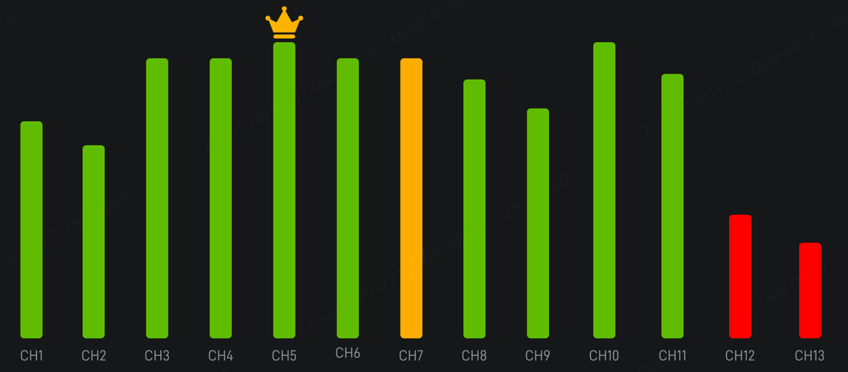
Meaning of scanning results:
- Green bars: Clean frequency points with no interference, recommended for use
- Yellow bars: Currently used frequency point
- Red bars: Frequency points with strong interference, not recommended for use
Click any frequency point bar to quickly switch to that frequency point.

13. Which products in the Pyro series are compatible with Pyro 7 Ultra?
Pyro 7 Ultra supports pairing with Pyro Ultra, Pyro 7, Pyro 5, Pyro 5 4K, Pyro S, Pyro H (unicast) devices within the same group (as transmitter or receiver); it can only be used with Vcore in receiver mode.

14. How to use the APP to connect to Pyro 7 Ultra for wireless monitoring?
Prerequisites:
- Pyro 7 Ultra must be in transmitter mode.
- non-Broadcast mode supports up to 2 APPs connecting simultaneously; broadcast mode does not support APP monitoring.
Operation steps:
- Open the phone's WiFi list, find the WiFi starting with "HLD_XXX", enter password 12345678 to connect
- Open the APP [HollyView], click [Add New Device] — select [Pyro Series]

Notes:
- Set the Pyro 7 Ultra frequency point to one of 1, 2, 11, 12, 13 to search for WiFi; iPhones have no frequency point restrictions.
- Turn off mobile data (4G/5G)
- Enable GPS location services on the phone

15. How to import and use 3D LUT?
LUT Import (via SD card or USB drive):
- Prepare a USB drive or SD card ≤32GB, format as FAT32 or NTFS (SD card can skip formatting)
- Copy .cube format LUT files to the root directory
- Connect the USB drive to the monitor via Type-C OTG adapter (or insert SD card directly into the slot)
- Swipe up on the screen to summon the bottom menu → Click "+" → Add [3D LUTs] from the right-side menu
- Click the menu bar icon  to open the 3D LUTs secondary menu, select one position from L1~L6, click the LUT file "+" and select the LUT file from the folder to overwrite
Supported LUT specifications for import: 16/17/32/33/64/65 bit, .cube format only.
Apply LUT:
- In the [3D LUTs] menu, directly click L1~L6 to switch to the corresponding LUT
LUT Effect Range Description:
- (SDI signal source) When transmitter (TX) enables LUT: TX loop-out, TX recording, RX screen display, RX output, RX recording all have LUT effect
- When receiver (RX) enables LUT: Only RX screen display and SDI OUT output have LUT effect, HDMI OUT and RX recording do not have LUT

16. How to record video? What formats are supported?
Recording steps:
- Insert SD card (maximum support 2TB) or USB drive
- Click the red recording button in the lower left corner of the screen to start recording, click again to stop
Recording notes:
- Recording resolution follows the input source (e.g., if input is 4K60, it records as 1080p60; if input is 1080p60, it records 1080p60)
- FAT32 format recording duration is approximately 9 minutes (around 4GB), EXFAT/NTFS format has no duration limit

17. How to perform device upgrade?
- Copy the upgrade file (.bin) to the root directory of a USB drive (≤32GB, FAT32 format) or SD card via computer
- Connect the USB drive to the monitor Type-C interface via OTG adapter (or insert SD card directly)
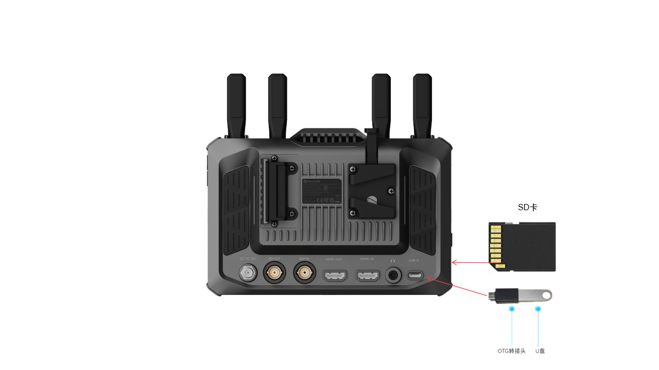3. The system will automatically pop up an upgrade prompt, click "Confirm"; or manually enter [Device Information] → Click "Latest System Version" → Confirm upgrade
4. Do not power off during the upgrade process, wait for the device to automatically restart to complete
Note: Please ensure that the wireless transmission function is enabled during the upgrade.

18. Does Pyro 7 Ultra support USB network cards for RTMP streaming? What are the network requirements?
Supported. Requires a USB network card with built-in data SIM card, connected to the Pyro 7 Ultra's Type-C interface in receiver mode via OTG adapter.
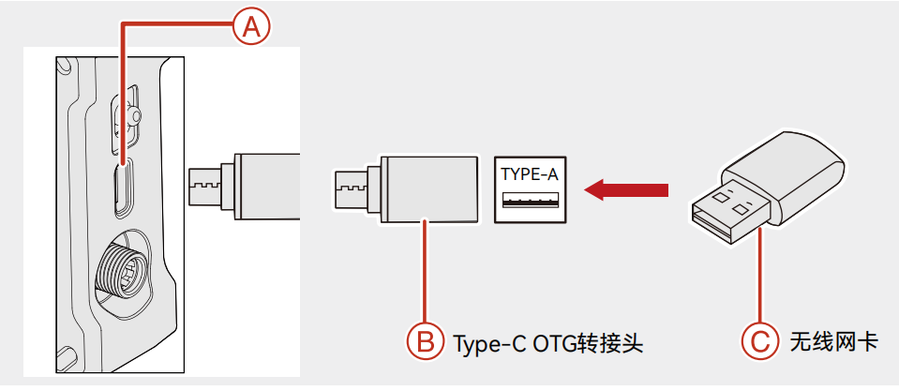
Network requirements: Upload bandwidth ≥6Mbps
Streaming bitrate: 6Mbps
Supported resolution: Up to 1080P60, encoding format H.264
Operation steps:
- After inserting the USB network card, the Type-C icon in the status bar changes to a globe (networking status)
- Phone connects to Pyro 7 Ultra's WiFi (in transmitter mode), open HollyView APP, enter RTMP streaming address
- Start streaming, when the globe icon changes to a camera icon with green arrow, it indicates successful streaming
PS: There are 2 types of USB network cards
1: USB Wireless Network Card =》After plugging in, it can provide the device with the ability to connect to wireless WiFi, not suitable for image transmission and small monitor devices
2: USB Network Card =》Contains a mobile data SIM card inside, after plugging in, it can directly provide package data traffic for the device, allowing the device to access the internet
Pyro 7 Ultra only supports solution 2 USB network cards

What is the "output resolution"?
Output resolution: Regardless of the input signal source resolution, you can set the HDMI OUT reception mode to 4K, 1080P, or adaptive. However, this only changes the resolution and not the frame rate. For example, if the input is a 4K 24p signal and the output resolution is set to 1080P, the receiver's HDMI OUT will output 1080P 24p resolution.

What frequency signals do the four antennas on the Pyro 7 Ultra transmit?
The left and right antennas transmit both 2.4GHz and 5GHz dual-band signals, while the two middle antennas transmit the 5GHz signal.

